**Lexar® JumpDrive® M400 USB 3.2 Gen 1 Flash Drive**

256GB

128GB

[Where to buy](https://americas.lexar.com/product/lexar-jumpdrive-m400-usb-3-2-flash-drive/)

**Key Features:**

Up to 150MB/s read

* Compact Design
* With Key Ring Loop
* Compatible
* 256-bit AES Encryption

**Key Features:**

Up to 150MB/s read

* Compact Design
* With Key Ring Loop
* Compatible
* 256-bit AES Encryption

**Key Features:**

Up to 150MB/s read

* Compact Design
* With Key Ring Loop
* Compatible
* 256-bit AES Encryption

**Key Features:**

Up to 150MB/s read

* Compact Design
* With Key Ring Loop
* Compatible
* 256-bit AES Encryption

[Features](https://americas.lexar.com/product/lexar-jumpdrive-m400-usb-3-2-flash-drive/#feature-section)[Specifications](https://americas.lexar.com/product/lexar-jumpdrive-m400-usb-3-2-flash-drive/#specifications)[Part Numbers](https://americas.lexar.com/product/lexar-jumpdrive-m400-usb-3-2-flash-drive/#product-numbers)[Related products](https://americas.lexar.com/product/lexar-jumpdrive-m400-usb-3-2-flash-drive/#related-products)

**Features**

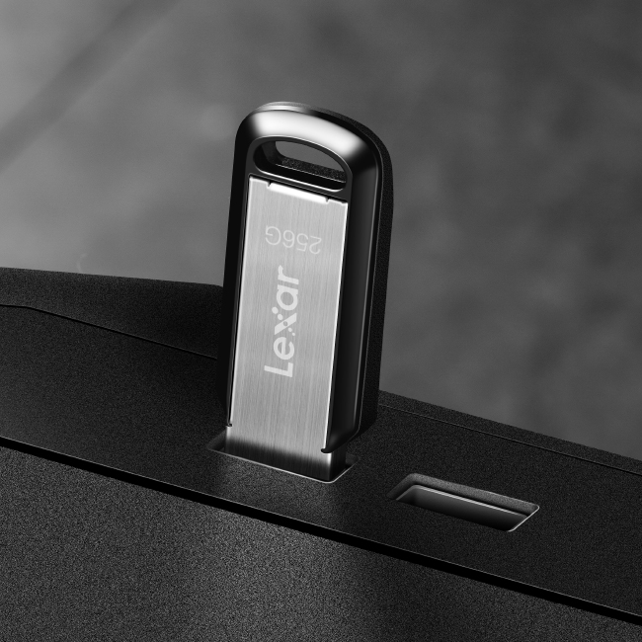

**Transfer Files with Speed and Style**

The Lexar® JumpDrive® M400 USB 3.2 Gen 1 Flash Drive moves your files faster with high-speed USB 3.0 performance of up to 150MB/s1 read. The stylish metal and key ring design lets you easily transfer files anywhere, anytime. And, with the Lexar DataShieldTM password protection, you can be certain your files will be protected.

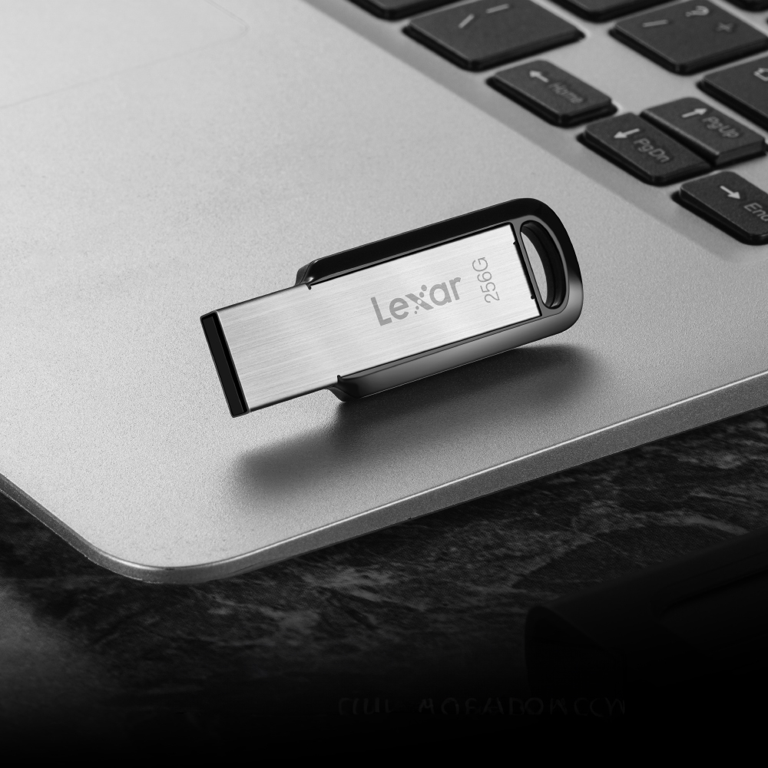

**Experience USB 3.2 Performance**

Transfer files faster with USB 3.2 Gen 1 performance. At a performance of 150MB/s1, your files will transfer in no time.

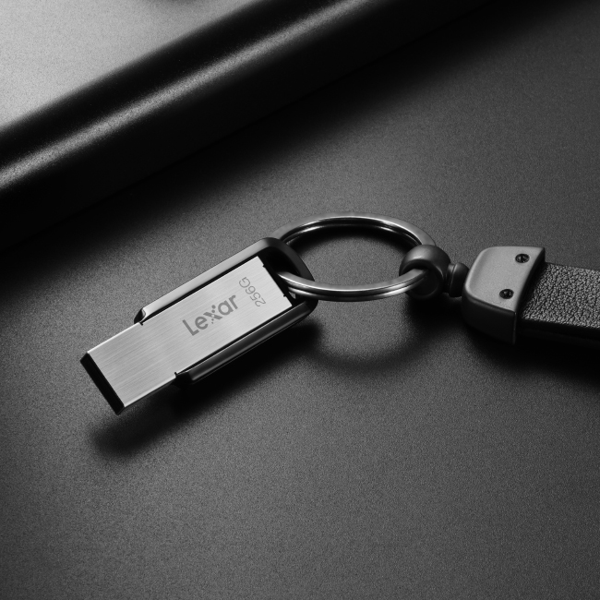

**Stylish and Durable**

With the stylish metal design, the JumpDrive® M400 USB 3.2 Gen 1 Flash Drive is ruggedly built for daily use. And with its included key ring, you can easily add it to a backpack or bag, making transferring files on the go a breeze.

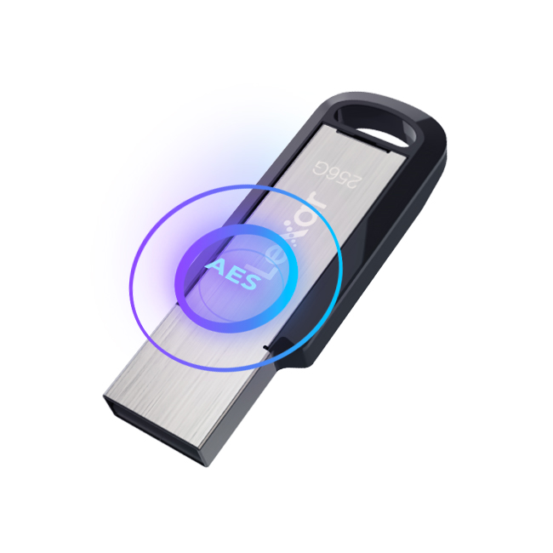

**Protect Your Files with Lexar DataShield**

The JumpDrive® M400 USB 3.2  Gen 1 Flash Drive is secured by Lexar DataShieldTM. The advanced security solution with 256-bit AES encryption2 helps to protect your essential files against corruption, loss, and deletion.

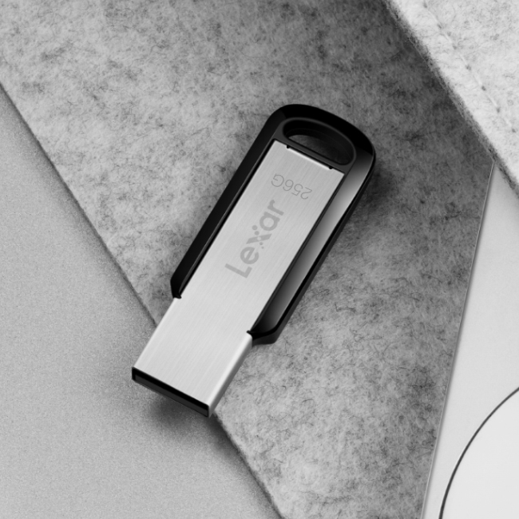

**Compatible with PC and Mac® Systems**

Compatible with both PC and Mac® systems, the JumpDrive® M400 USB 3.2 Gen 1 Flash Drive allows you to easily store a large number of photos, videos, and documents.



**Rigorously Tested**

All Lexar products undergo extensive testing in the Lexar Quality Labs, facilities with thousands of different cameras and digital devices to ensure performance, quality, compatibility, and reliability.

**Specifications**

* Capacity

256GB | 128GB

* Interface

USB 3.2

* Performance

128GB – Up to 150MB/s¹  
256GB – Up to 150MB/s¹

* Operating Temperature

0°C ~ 50°C (32°F to 122°F)

* Storage Temperature

-10°C ~ 70°C (-1°F to 158°F)

* Dimension (L x W x H)

47.2mm x 16.3mm x 6.2mm / 1.858” x 0.642” x 0.244”

* Weight

4.82 g

* Warranty

Five-year limited warranty